**INSTALLING ALTIUM**

This tutorial is meant to set you up with the Altium Software. You will need to be on the UF network to properly install Altium using our method. If you are not currently on UF Wi-Fi, you can go to the following link to download a remote access VPN: <https://connect.ufl.edu/it/wiki/Pages/glvpn-anyconnect-install.aspx#mac-acinstall>.

1. Follow the below link and click on the .zip download:

<ftp://altiumdownload.ece.ufl.edu/pub/Altium%20Install/Altium%2019/Altium%2019%20zip/>

1. Once finished downloading, extract the files to whatever destination you want.
2. Once inside your destination folder, click on the AltiumDesigner19Setup.exe file.

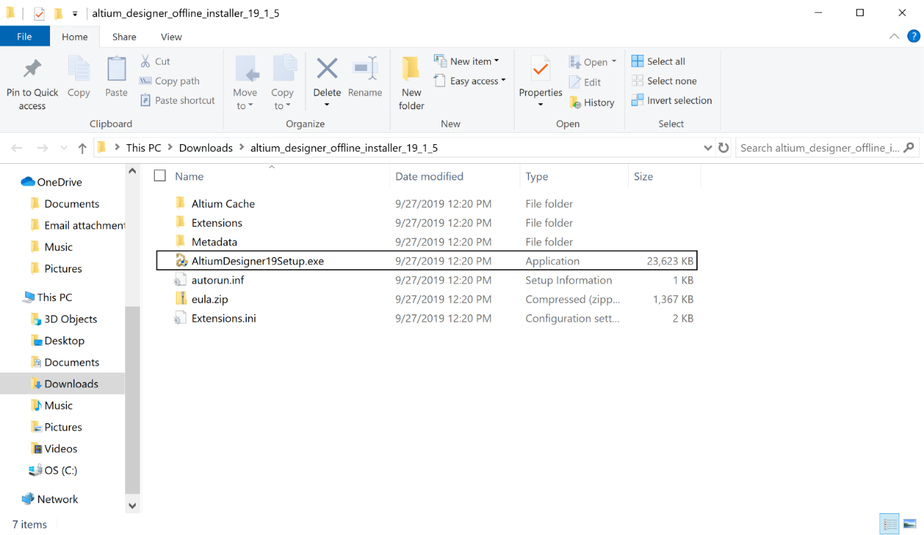

1. Follow through the default installation settings as shown below.

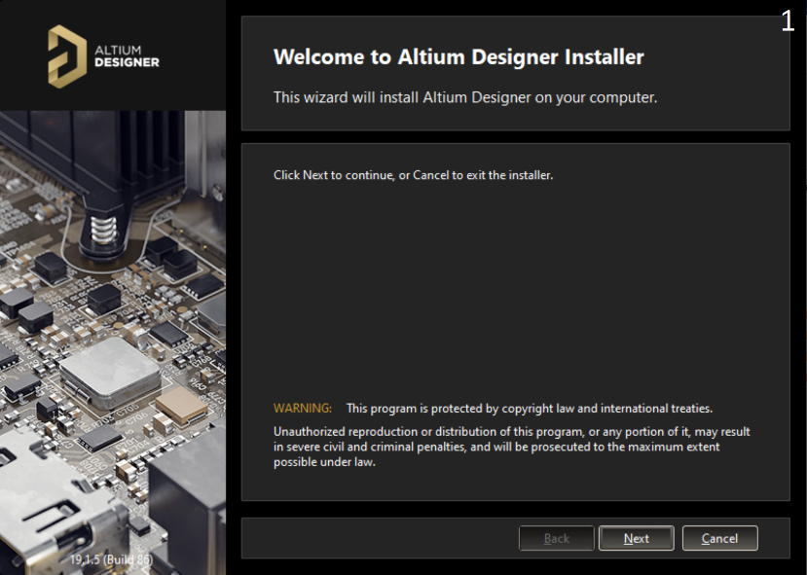 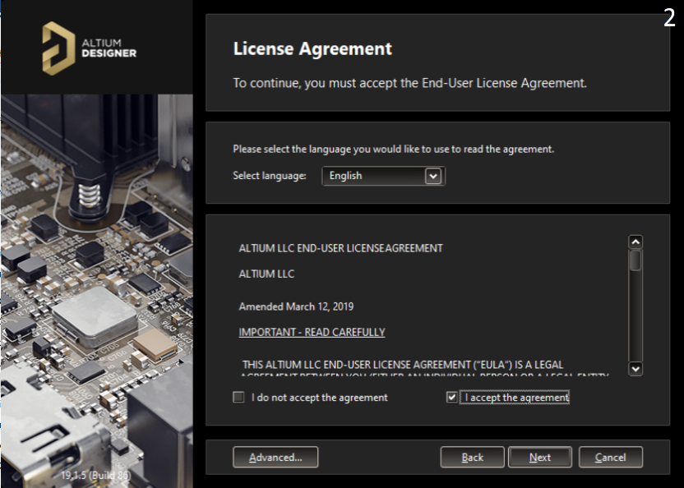

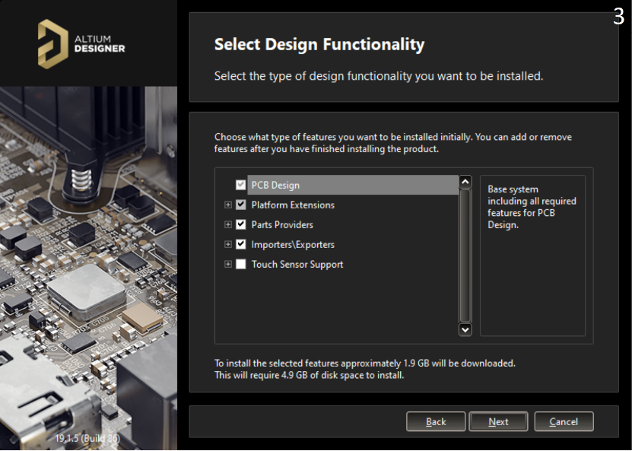 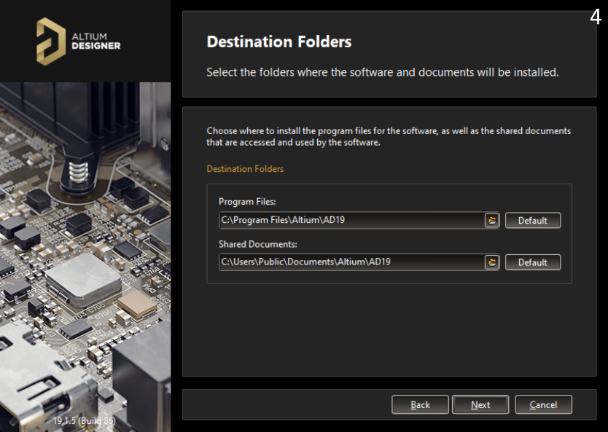

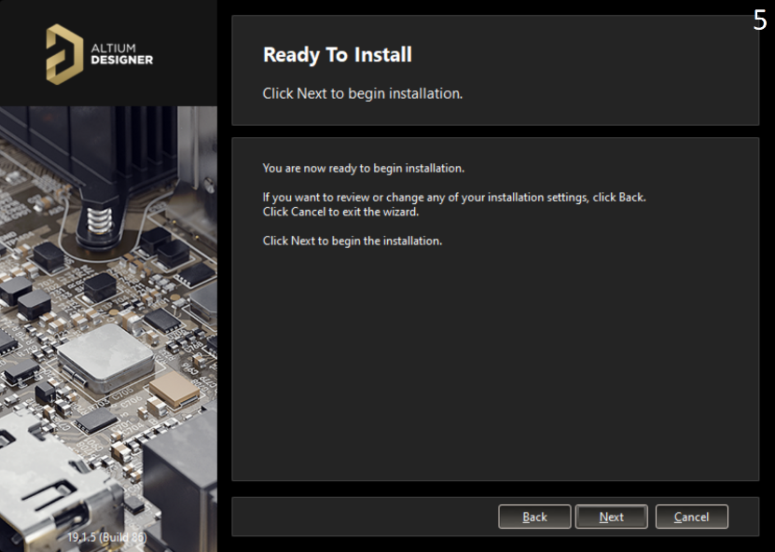 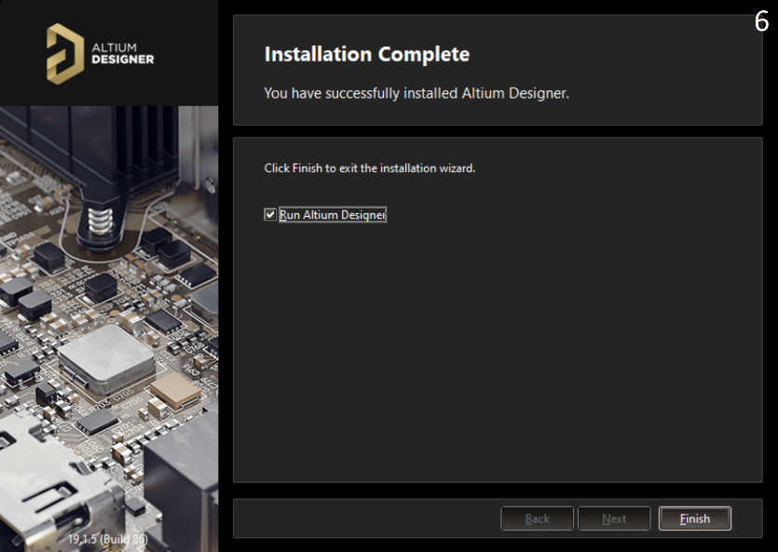

1. Once installed and opened you should see the below screen:
2. Click on “Setup Private License Server”

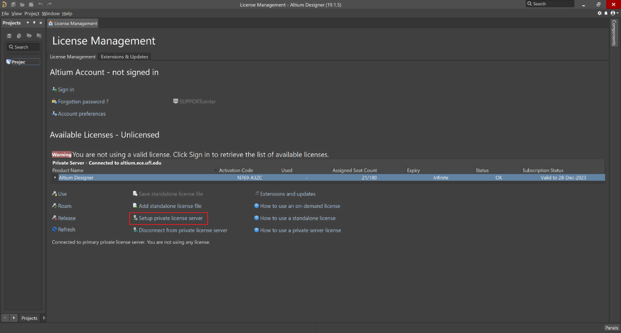

1. Set up the screen as shown below:

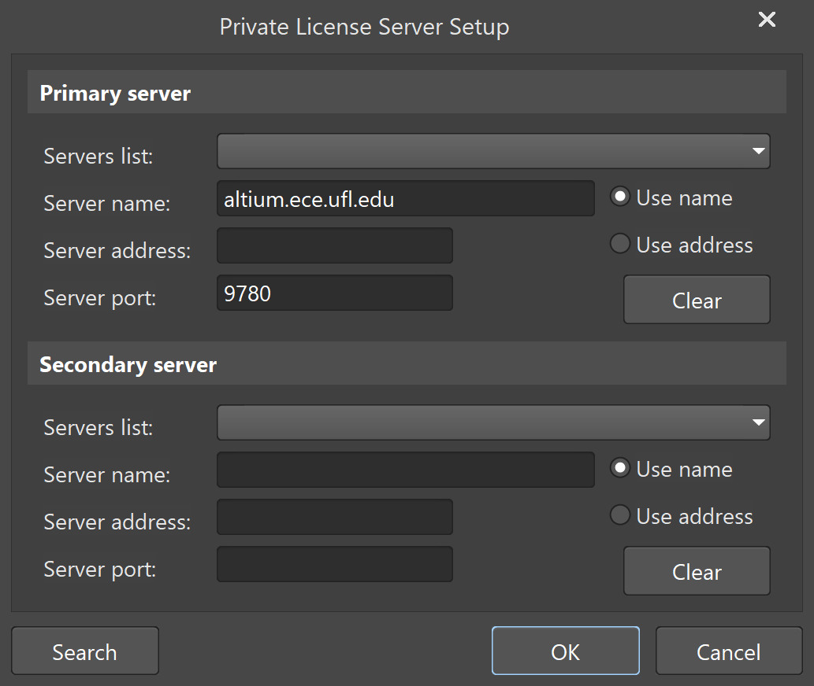

1. If you did everything correctly, you should see the following screen:

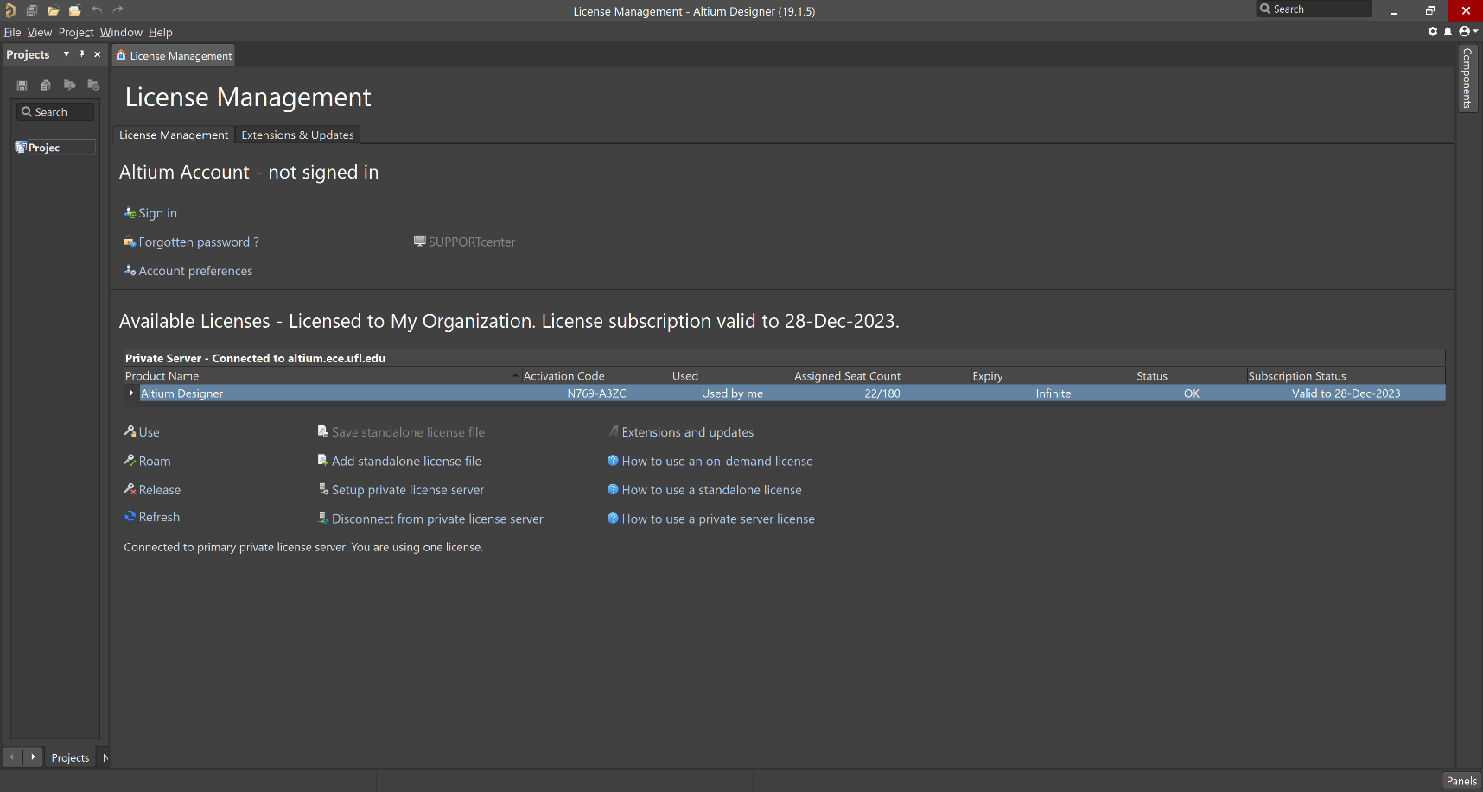

1. You should now be able to select the highlighted line beneath “Product Name” and click “Use” below that to unlock the software.